Activity

Hospital Billing and Patient Classification

- Problem Statement

Design a Python program to estimate the financial feasibility of a campus event. The program receives fixed event costs, per-participant costs, expected registrations, registration fee and sponsorship. It computes total cost, income, surplus or shortfall, and the minimum number of registrations required to break even. Invalid negative numeric inputs must be rejected.
2. Objectives

• Read event name and eight numeric financial inputs.
• Validate that costs, participants, fee and sponsorship are non-negative.
• Separate fixed and per-participant variable costs.
• Calculate total event cost, participant contribution, income and balance.
• Classify the outcome as surplus or sponsorship shortfall.
• Use a while loop to find minimum registrations when break-even is possible

. 3. Assumptions

• All amounts are in Indian rupees (Rs.) and inputs are numeric
. • Venue, equipment and transport are fixed costs; catering and certificate expenses apply per participant.
• Every expected participant pays the same registration fee; no additional income or expenses are considered.
• Sponsorship is a fixed amount, independent of participant count.
• Zero participants and zero-valued financial inputs are allowed; negative numeric values are invalid.
• A non-negative balance is labeled financially successful, including exactly break-even.
• Minimum registrations are calculated using the same fee and variable cost for every additional participant, with no capacity limit.
• The original program uses repeated addition in a while loop; very large break-even

4. Formulas •
Fixed cost = venue + equipment + transport
• Variable cost per participant = catering + certificate
• Total cost = fixed cost + participants × variable cost
• Participant contribution = participants × registration fee
• Total income = participant contribution + sponsorship
• Balance = total income − total cost
• Amount needed = fixed cost − sponsorship Campus Event Case Study | Page 1
• Margin per participant = registration fee − variable cost
• If amount needed ≤ 0, minimum registrations = 0; otherwise, when margin > 0, increment minimum until minimum × margin ≥ amount needed.

5. Step-by-Step Algorithm
1. START and read event name.
2. Read venue, equipment, catering, transport, certificate, participants, registration fee and sponsorship.
3. If any numeric input is negative, display Invalid input and STOP.
4. Calculate fixed_cost and variable_cost.
5. Calculate total_cost, contribution, total_income and balance.
6. Display event name, total cost, contribution, sponsorship and income.
7. If balance ≥ 0, display financially successful and surplus; otherwise display sponsorship shortfall = −balance.
8. Calculate amount_needed = fixed_cost − sponsorship and margin = registration_fee − variable_cost.
9. If amount_needed ≤ 0, print minimum registrations = 0.
10. Else if margin ≤ 0, print break-even is not possible.
11. Otherwise initialize minimum = 0; while minimum × margin < amount_needed, increment minimu

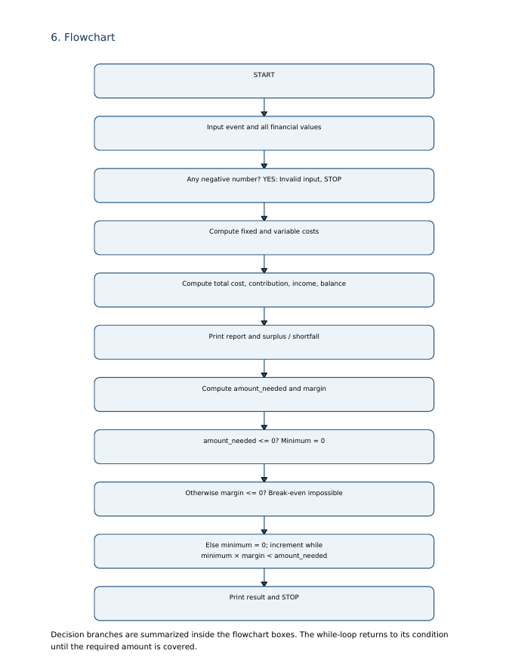

Pseudo code

INPUT event, venue, equipment, catering, transport
INPUT certificate, participants, registration_fee, sponsorship
IF any numeric input < 0 THEN
PRINT "Invalid input"
ELSE
fixed_cost <- venue + equipment + transport
variable_cost <- catering + certificate
total_cost <- fixed_cost + participants * variable_cost
contribution <- participants * registration_fee
total_income <- contribution + sponsorship
balance <- total_income - total_cost
PRINT event, total_cost, contribution, sponsorship, total_income
IF balance >= 0 THEN
PRINT "Financially Successful", balance
ELSE
PRINT "Sponsorship Shortfall", -balance
ENDIF
amount_needed <- fixed_cost - sponsorship
margin <- registration_fee - variable_cost

IF amount_needed <= 0 THEN
PRINT "Minimum Registrations: 0"
ELSE IF margin <= 0 THEN
PRINT "Break-even is not possible"
ELSE
minimum <- 0
WHILE minimum * margin < amount_needed DO
minimum <- minimum + 1
ENDWHILE
PRINT minimum
ENDIF
ENDIF
END

9. Line-by-Line Explanation

• 1: Reads the event name as a string.
• 3–7: Reads venue, equipment, catering, transport and certificate costs as floating-point values.
• 9–11: Reads expected participants, registration fee and sponsorship.\
• 13–17: Checks all numeric inputs for negative values using logical OR.
• 18: Displays an error if any value is negative.
• 19: Starts calculations only when all numeric inputs are valid.
• 20: Adds venue, equipment and transport to find fixed cost.
• 21: Adds catering and certificate to find variable cost per participant.
• 23: Calculates the total cost for the expected participants.
• 25: Computes registration income from participants.
• 27: Adds sponsorship to participant contribution.
• 29: Subtracts total cost from total income.
• 31–36: Prints the financial report and rounded amounts.
• 38–43: Prints success and surplus if balance is non-negative; otherwise prints the positive shortfall
. • 45: Computes the remaining fixed cost after sponsorship.
• 46: Computes net contribution per additional participant.
• 48–50: If sponsorship already covers fixed costs, zero registrations are needed.
• 51–52: If margin is zero or negative and fixed cost is not covered, break-even is impossible.
• 53–54: Initializes the counter for a possible break-even calculation.
• 56–57: Repeats the loop, increasing minimum until its total margin covers the amo

Testcase

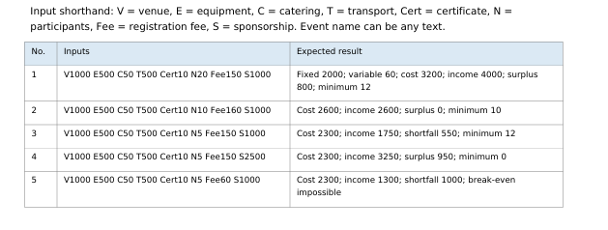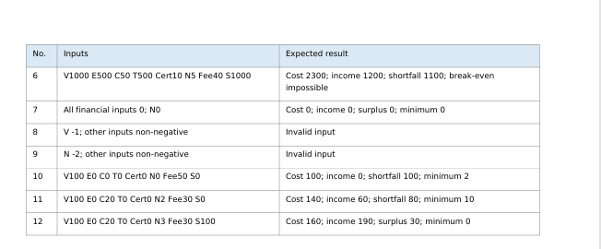

My out put

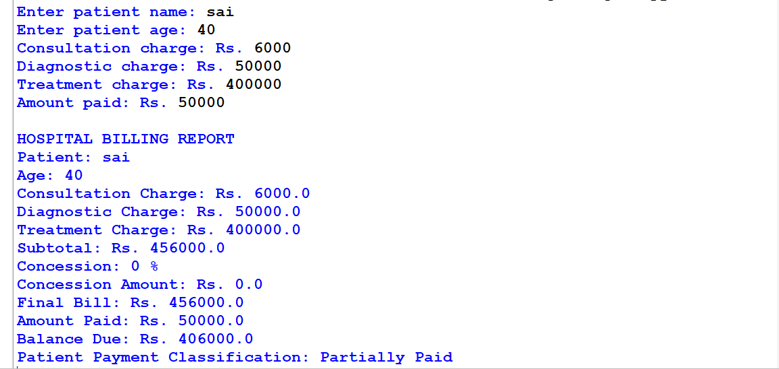

Conclusion
Conclusion The program demonstrates financial planning with Python fundamentals, input validation, conditional decisions, arithmetic, string output and a while loop. The break-even calculation distinguishes sponsorship already covering fixed costs from cases in which additional participants can or cannot cover the remaining cost

